Lab 6 - Forms

Instructions
- Answer the below question in the boxes if needed.
- For coding exercises, code on your computer and zip all your code before submission.
- Please submit the assignment after you finish.

Part 1: Form Input Types
Steps:

- Go to VS Code and open the folder that we created in Lab 1
- Create a new html file and name it as "form.html" inside the folder. You can use the HTML skeleton we included in Chapter 1.
- Build form elements inside the body to replicate the screenshot below
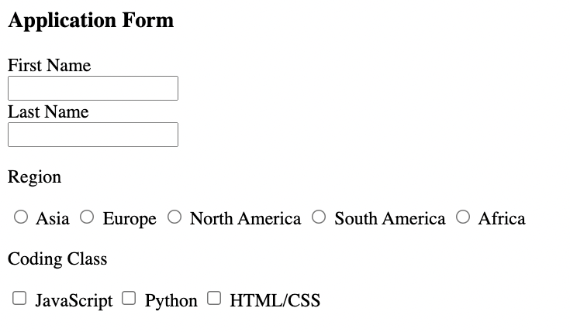

Part 2: For Input Attributes

- Set a constraint on the first name and last name input element so that not more than 20 characters can be entered. Set a placeholder that says “20 letters only”.

Part 3: Other Form Elements

- Create a dropdown menu with “select” for people to pick their coding experiences. There should be 3 options (No Experiences, Some Experiences, Extensive Experiences). It should look like the screenshot below:
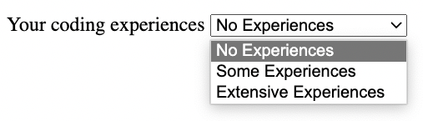

- Add a textarea below the dropdown menu, with a label that says “Any other comments for your application”. It should look like the screenshot below:
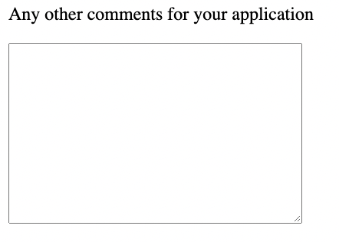
- Submit the final HTML file.

